Work Smart

Lync 2013 for Windows Phone 8

**Customization note:** This document contains guidance and/or step-by-step installation instructions that can be reused, customized, or deleted entirely if they do not apply to your organization’s environment or installation scenarios. The text marked by yellow highlighting indicates either customization guidance or organization-specific variables. All of the highlighted text in this document should either be deleted or replaced prior to distribution.

Lync 2013 for Windows Phone is an app that brings Lync presence, instant messaging (IM), voice, and video capabilities to your mobile device. You can choose from multiple ways to communicate with others by using either Wi‑Fi only or your cellular data connection when you’re not connected to Wi‑Fi.

To get Lync 2013 for Windows Phone, you need Windows Phone 8. From your phone, go to the Windows Store, search for Lync 2013, and then tap **Install**. As soon as the app is installed, it appears on your phone. When you set up your Microsoft Exchange Server email account on your phone, by default, you’ll be guided to install Lync.

Important Note: Using the Lync Mobile client can increase your mobile data usage. Depending on the type of mobile data plan you subscribe to, this may cause an increase in your mobile phone bill.

## Topics in this guide include:

More Information

Signing in to Lync

Call Forwarding and Voice Mail

Contacts

Meetings

Status and personal note

Conversations

# Signing into Lync for the first time

Before you start Lync, make sure your phone is connected to Internet through either your data plan or a Wi‑Fi network.

1. On the sign-in screen, enter your user name (*alias*@*company*.com) and password.
2. Tap **Next** Icon 11.

Note: Tap **More** Icon 5 if you need to enter your server information.

1. The first time you sign in to Lync, you will be asked whether you want to make Lync audio and video calls only when connected through a Wi‑Fi network or also when using your cellular data connection. After you have made your selections on the **Set up work calls** screen, tap **Next** Icon 11**.**

* By default, **Require Wi‑Fi for VoIP** is set to **OFF**, which means that Lync will use Wi‑Fi to make Lync calls. When you’re not connected to Wi‑Fi, you can use your data cellular data connection or mobile minutes, instead.
  + Require Wi‑Fi for VoIP calls: **OFF**
  + Lync might use your cellular data connection to make and receive audio calls when you are not connected to a Wi‑Fi network. If you are connected to Wi‑Fi, Lync tries to use the Wi‑Fi network for audio calls, instead.
    - If you’re not connected to Wi‑Fi when you make an audio or video call, Lync calls you back at the number you specify. For these calls, you’re connected to the audio portion of the Lync call only. Video isn’t available for that call. This might result in use of your mobile voice plan minutes.
  + Require Wi‑Fi for VoIP calls: **ON**
    - Lync won’t use your cellular data connection to make or receive calls.
    - If you’re connected to a Wi‑Fi network, Lync tries to use Wi‑Fi for calls.
    - If you’re not connected to Wi‑Fi when you make an audio or video call, Lync calls you back at the number you specify. For these calls, you’re connected to the audio portion of the Lync call only. Video isn’t available for that call, which might result in use of your mobile voice plan minutes.
* By default, **Require Wi‑Fi for video** is set to **ON**. This means Lync will use only Wi‑Fi to make Lync video calls.
  + Require Wi‑Fi for Video calls: **OFF**
    - Lync might use your cellular data connection to send and receive video when you’re not connected to a Wi‑Fi network. If you are connected to Wi‑Fi, Lync tries to use the Wi‑Fi network for video, instead.
    - Video isn’t available for calls connected via your mobile number over the cellular voice network.
  + Require Wi‑Fi for Video calls call: **ON**
    - Lync won’t use your cellular data connection to send or receive video.
    - If you’re connected to a Wi‑Fi network, Lync tries to use Wi‑Fi for video.

1. Enter your Windows Phone number with country/region codes (this should prepopulate any call-forwarding or simultaneous ring settings that are set up in Lync for the desktop). If Lync cannot use the Wi‑Fi or cellular data network to make an audio or video call, Lync will call you back at this number to connect you to the audio portion of the Lync call. When you’ve finished entering your number, tap **Next** Icon 11.
2. On the next screen, confirm any changes you’ve made, and then tap **Next** Icon 11 to allow your work calls to simultaneously ring on your mobile phone.
3. To receive an alert when a Lync contact is trying to reach you, on the **Turn on Lync push notifications?** screen, tap the **check** **mark** icon.
4. Tap **Done** to start using Lync.

Note: To make changes to your call settings, on the **My info** screen, tap **More** Icon 5, then tap **settings**.

# Status and personal note

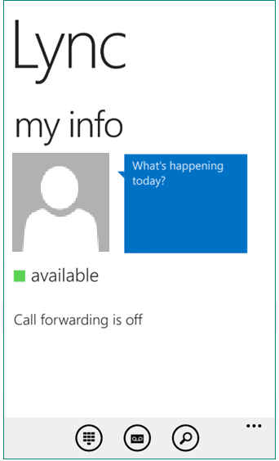Your presence information includes availability status such as Available or Away and is also indicated by a color-coded presence indicator such as green, yellow, or red. When you are using Lync on your mobile device, it will indicate to people who view your contact information that you are currently using a mobile device.

## Statuses you can set

To change your status, on the **My info** screen, tap your current status. Then, on the **SET YOUR STATUS** screen, select one of the following presence statuses:

Available

Busy

Do Not Disturb

Be Right Back

Off Work

Appear Away

Reset Status

Sign Out

## Statuses that are set automatically

When you’re signed in, you remain signed in as long as there is connectivity. If you are in a meeting or on a call, your status will be updated automatically. If you’re not actively using the app on your mobile device or Lync on your computer, your status appears as **Inactive**. If you have connectivity but haven’t used the app for 10 days, you’re signed out.

## Set a personal note

On the **My info** screen, in the note area, type any kind of note you want. The note appears with your contact card. When you change your **Automatic Replies** (Out of Office) settings in Microsoft Outlook, the note you type there also appears in the personal note area in Lync. This note stays in Lync until you cancel the note in Outlook or type a new note.

# Contacts

## Find a contact

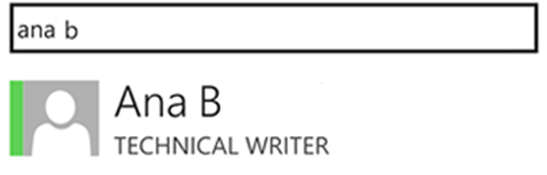From the **Contacts** screen, tap **Search** Icon 6, and then start typing a name, phone number, direct extension, or email address in the search box.

The results are displayed below the box. If **Phonebook Integration** is set to **ON**, when you search for a contact, the search results will also find contacts on your mobile phone. You can go to **settings** and set the **Phonebook Integration** setting to on or off.

## View your Contacts list

To view your Contacts list, go to the **Contacts** screen, and then tap any of the groups to expand the group. The Contacts list in Lync 2013 on the desktop is the same as the one in the Lync app (the Recent Contact group isn’t available on your mobile device). If you have to make changes to your Contacts list, you’ll need to do it from Lync running on your desktop. You can only view your Contacts list from the Lync for Windows Phone app, not make changes to it from the app.

## View someone’s contact card

The contact card displays status, personal note, and office location about people and provides several ways to communicate with someone. For example, you can send an instant message, start an audio or video, or send an email message directly from someone’s contact card. Find the contact in your Contacts list, or start typing a person’s name in the search box. When you find the contact you’re looking for, tap the person’s name, and then tap the **Contact card** icon.

# Conversations

## Starting a conversation

From Lync, you can start a chat (IM), a voice call, or a video call with a single tap on a contact’s name.

* Type your message, and then tap the **Send** icon.
* You can also add audio or video to an existing IM conversation by tapping the **call** or **video** icon on the app bar.
* To call someone at their work or mobile number, tap their contact name, and then tap the **Contact card** icon. Select the number you’d like to call.

**Joining a conversation**

* **IM.** When someone sends you an instant message and you’re in Lync, a notification appears at the top of the screen. To accept the invitation, tap the notification. If you receive an instant message while your phone is locked or Lync is running in the background, a native Windows Phone notification appears indicating that you have a new instant message. To accept the invitation, tap the notification. To ignore the invitation, just let the notification time out.
* **Audio.** When you get a Lync call, it looks the same as any other call you get on your Windows Phone. The only difference is that when you get the call, the ringtone will be the default Lync ringtone (this ringtone can’t be changed), and the incoming call screen will have a Lync logo on the left.
* **Video.** When you receive a Lync video call, tap **video** to accept an incoming audio or video call, or tap **audio** to accept an audio-only call.

## Switch between conversations

To switch between conversations, at the bottom, tap **More** Icon 5, and then tap **view conversations**. From the **Conversions** screen, tap the conversation you want to see.

## Find recent or missed conversations

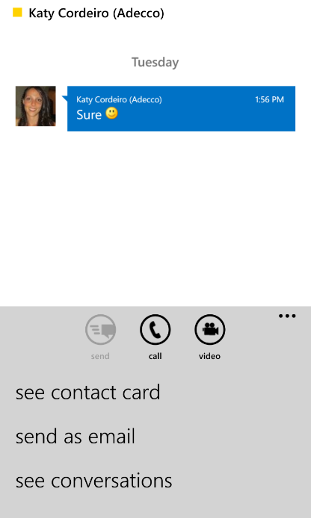To view a missed or recent conversation, go to the **Conversations** screen. A list of recent and missed conversations is displayed. Tap the conversation to reply.

Note: The conversations history in Lync for Windows Phone is not synced with Exchange Server. This means that conversations that occur on your Lync mobile device will be displayed only in that device’s conversation history and nowhere else. Conversations that you accepted on other Lync clients don’t appear on the **Conversations** screen.

## Delete a conversation

To delete a conversation from the **Conversations** screen, tap and hold the conversation you want to delete. When you see the menu options, tap **delete conversation**.

# Meetings

## Join a Lync Meeting

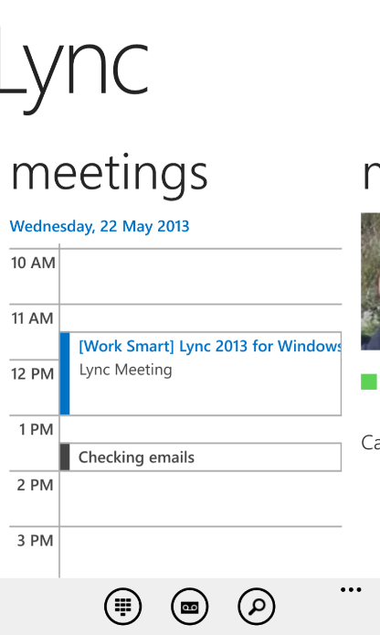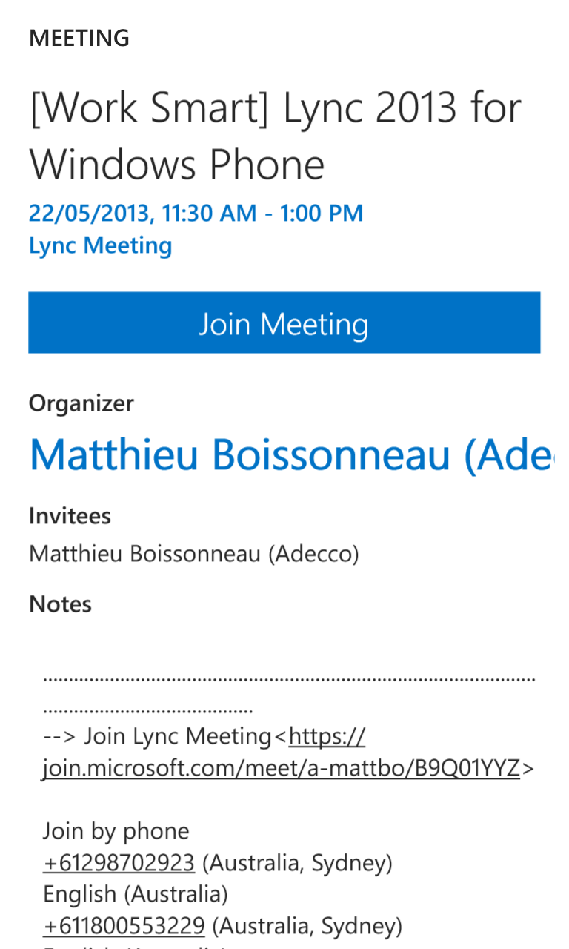To join a Lync Meeting, from the **Meetings** screen, select the meeting you want to join, and then tap **Join Meeting** or the meeting hyperlink.

When you join a Lync Meeting using Lync for Windows Phone, you can only hear the meeting audio a nd see the video of other participants (if it’s being shown). You won’t be able to see any meeting content being shared.

If you’ve joined a meeting from your mobile device, and then you join the same meeting from your desktop computer, you’ll stay connected to the meeting audio on your mobile phone and connect to the visual part of the meeting on your desktop computer. We recommend that you connect only to the meeting audio and video on either your mobile device or your desktop computer.

## Waiting in the meeting lobby

The meeting lobby is an online waiting area. The meeting leader can control access to the meeting or admit someone who doesn’t have the correct meeting credentials. If the meeting leader has enabled the meeting lobby, you’ll need to wait until the meeting leader admits you to the meeting. If you’re waiting in the lobby, don’t move to another screen: Your request to join the meeting will be cancelled if you do.

## Run a Lync Meeting

To view and share Lync Meeting content, you must connect to the meeting by using Lync on your desktop computer.

## What you can do in a Lync Meeting

Remember that when you join an audio or video meeting on Lync for Windows Phone, you won’t be able to see the meeting content. When you’re in a call, tap the:

* **Mute** icon to mute and unmute the call
* **Hold** icon to put the call on hold, and then tap the **Hold** icon again to resume the call
* **Speaker** icon to turn the speakerphone on and off
* **Dial pad** icon to use the dial pad
* **End call** icon to end the entire conversation
* **IM** icon to view or send an instant message to people in the call, and then tap the **Phone** icon to go back to the audio conversation
* **Video** icon to start your video

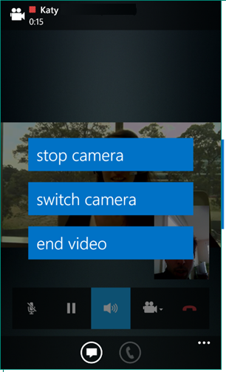When you’re in video call, tap the **Video** icon, and then tap one of the following:

* **stop camera** to turn off your video but still see another person’s video
* **switch camera** to switch from the front or back Windows Phone camera
* **leave video** to end everyone’s video for you only but still have audio

At the bottom of the screen, tap the **More** icon, then tap:

* 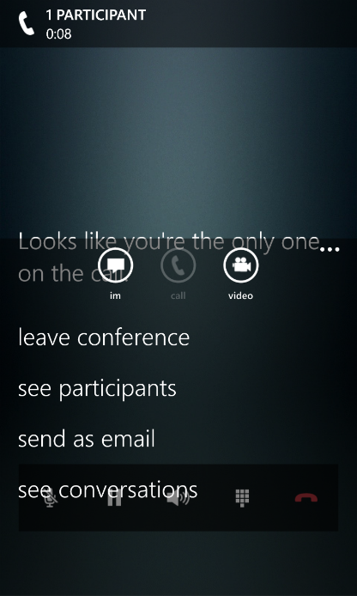**leave conference** to leave the meeting
* **see participants** to view the participants’ list in the meeting
* **send as email** to send an email copy of your conversation to someone
* **see conversations** to view current and past conversations

# Call forwarding and voicemail

You can set up call forwarding and simultaneously ring so that you don’t miss calls. Call forwarding is especially useful if you’re traveling or working from home, because you can forward calls to your current location. If you’re out of the office, you can automatically forward calls to a co-worker.

The Simultaneously Ring option is handy for people on the go. When you get a call, it rings at two phone numbers at the same time. You can set your incoming calls to simultaneously ring your phone and another number or contact in case you’re busy or momentarily unavailable.

## Forward calls

The Call Forwarding option is typically used to forward calls to voicemail or to a number other than your mobile number. When you set call forwarding settings in Lync, all incoming calls are automatically forwarded to the destination you choose.

1. From the **My Info** screen, tap **Simultaneously Ring** or **Call Forwarding**.
2. On the **Call Forwarding** screen, tap **Forward Calls**, and then complete one of the tasks:
   1. Tap **voicemail** to have the call sent to your voice mail, where you can retrieve it later.
   2. Tap and select a number you’ve added before, such as your mobile phone.
   3. Click **New Number**, and type in a new phone number.
   4. Tap **New Contact**, and then search a contact in the dialog box that appears.
3. Under **Apply settings during these hours**, select when this setting should apply.
4. Tap **Done** to save your changes.

## Stop call forwarding

To stop call forwarding, complete the following steps:

1. From the **My Info** screen, tap **Simultaneously Ring** or **Call Forwarding**.
2. On the **Call Forwarding** screen, tap **Do not Forward** calls.
3. Under **Apply settings during these hours**, select when this setting should apply.
4. Tap **Done** to save your changes.

## Set up simultaneously ring

Unlike call forwarding, where your work phone doesn’t ring, you can set your incoming calls to simultaneously ring your phone and another number or contact. This setting can help ensure that callers don’t get a busy signal and you don't miss their calls. At the same time, callers won’t be aware that their call was forwarded.

1. From the **My Info** screen, tap **Simultaneously Ring** or **Call Forwarding**.
2. On the **Call Forwarding** screen, tap **Simultaneously Ring**, and then complete one of the following tasks:
   1. Tap **New Number** and type in a new phone number.
   2. Tap and select a number you’ve added before, such as your mobile phone.
3. Under **Apply settings during these hours**, select when this setting should apply.
4. Tap **Done** to save your changes.

## Voicemail

Your voicemail messages are saved in both Lync and Outlook. When you have new voicemail, the **voicemail** icon at the bottom displays the number of messages. To listen to a voicemail message, tap the **voicemail** icon, and then play the message. To reply to the message, tap it to open the sender’s contact card and reply using IM, audio call, or video call.

# For more information

Windows Phone Lync 2013

<http://www.windowsphone.com/en-us/store/app/lync-2013/d85d8a57-0f61-4ff3-a0f4-444e131d8491>

Windows Phone

<http://www.windowsphone.com/en-us>