Integrating Microsoft Lync Server 2013 and Cisco ISR 3845

Document Revision History
Version | Reason for Change | Date | Created/Updated by
1.0 | Initial Draft for Lync 2013 | 10/16/2013 | Srikanth Jonnada

Table of Contents
1 Topology 3
2 Components Information 4
Cisco ISR 3845 Gateway 4
3 Configuration Overview 5
3.1 Lync Server 2013 5
3.2 Cisco ISR Gateway 5
4 ISR 3845 Configuration 6
5 Lync Server Configuration 14
5.1 Add Cisco ISR Gateway to Lync Topology 14
5.2 Trunk Configuration 18
5.3 Route 22
5.4 Voice Policy and PSTN Usage 23
5.5 Dial Plan 26
5.6 Configure Media Bypass 27

Topology

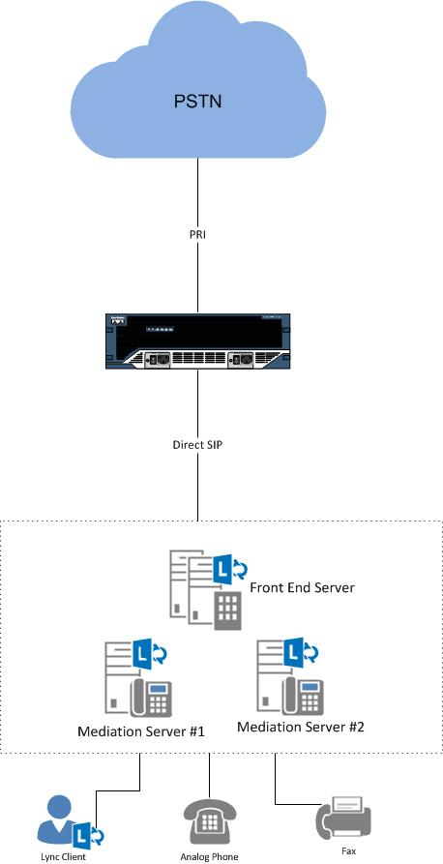
Figure 1: Deployment Topology

Components Information

Lync Server 2013 Version

Vendor | Microsoft
Models | Lync Server 2013
Software Version | RTM: Release 2013 5.0.8308.0
VoIP Protocol | SIP
Additional Notes | None

Cisco ISR 3845 Gateway
Vendor | Cisco
Models | ISR Gateway 3845
Software Version | 15.1-4.M6
VoIP Protocol | SIP
Additional Notes | None

Configuration Overview
Call transfer on Lync Client with REFER fail, so REFER is disabled. As REFER is disabled and Media Bypass is enabled on the trunk, Lync Server makes it mandatory to disable RTCP and enabled Session Timer on the trunk.

Lync Server 2013
Feature | Configuration
REFER | Disabled
Media Bypass | Enabled
Session Timer | Enabled
RTCP | Disabled
EncryptionLevel | Support Encryption

Cisco ISR Gateway
Feature | Configuration
PRACK/reliable early media | Disabled

ISR 3845 Configuration
Current configuration : 10627 bytes
!
! Last configuration change at 19:13:12 UTC Wed Oct 16 2013 by cisco
version 15.1
service timestamps debug datetime msec
service timestamps log datetime msec
no service password-encryption
!
hostname ciscogd2
!
boot-start-marker
boot system flash c3845-adventerprisek9-mz.151-4.M6.bin
boot-end-marker
!
card type t1 2 1
logging buffered 51200 warnings
enable password tekV1z10n
!
no aaa new-model
!
no network-clock-participate slot 2
!
dot11 syslog
ip source-route
!
ip cef
!
ip domain name lab.tekvizion.com
ip name-server 10.64.1.3
no ipv6 cef
!
multilink bundle-name authenticated
!
isdn switch-type primary-ni
!
voice-card 0
dsp services dspfarm
!
voice-card 2
!
voice service voip
ip address trusted list
ipv4 0.0.0.0 0.0.0.0
ipv4 10.85.0.252
rtcp keepalive
allow-connections sip to sip
no supplementary-service sip refer
supplementary-service media-renegotiate
sip
min-se 600 session-expires 600
asserted-id pai
midcall-signaling passthru
privacy-policy passthru
privacy-policy send-always
sip-profiles 1
block 181
!
voice class codec 1
codec preference 1 g711ulaw
codec preference 2 g711alaw
!
voice class sip-profiles 1
request INVITE sip-header Expires remove
request INVITE sip-header Session-Expires add "Session-expires: 600"
!
voice translation-rule 1
rule 1 /\(..........\)/ /+1\1/
!
voice translation-rule 2
rule 1 /\+1\(..........\)/ /\1/
!
voice translation-rule 3
rule 1 /\(..........\)/ /+\1/
!
!
voice translation-profile toAnalog
translate called 3
!
voice translation-profile toLync
translate called 1
!
voice translation-profile toPRI
translate called 2
!
!
!
application
service dsapp
param dialpeer 7
param callHold TRUE
!
!!
controller T1 2/0
pri-group timeslots 1-24
!
interface GigabitEthernet0/1
ip address 10.64.3.36 255.255.0.0
duplex full
speed 100
media-type rj45
!
interface Serial2/0:23
no ip address
encapsulation hdlc
isdn switch-type primary-ni
isdn timer T310 300000
isdn not-end-to-end 64
isdn incoming-voice voice
isdn map address .* plan isdn type national
no cdp enable
!
ip default-gateway 10.64.1.1
ip forward-protocol nd
ip http server
ip http secure-server
!
ip route 0.0.0.0 0.0.0.0 10.64.1.1
ip route 10.0.0.0 255.0.0.0 GigabitEthernet0/1
!

control-plane
!
!
voice-port 2/0:23
!
mgcp profile default
!
!
dial-peer voice 1 voip
description outgoing to Lync
translation-profile outgoing toLync
huntstop
rtp payload-type comfort-noise 13
session protocol sipv2
session target dns:medpool.lynclabkm2013.local
session transport tcp
incoming called-number .
voice-class codec 1
voice-class sip localhost dns:ciscogd2.lab.tekvizion.com
no voice-class sip early-offer forced
no voice-class sip block 183
no voice-class sip block 181
voice-class sip options-keepalive
dtmf-relay rtp-nte
!
dial-peer voice 1852263 pots
translation-profile outgoing toPRI
destination-pattern +1[2-9]..[2-9]......$
no digit-strip
direct-inward-dial
port 2/0:23
!
dial-peer voice 2 pots
destination-pattern 8522617
clid network-number 9728522617
port 0/0/0
!
dial-peer voice 3 pots8
destination-pattern 8522618
clid network-number 9728522618
port 0/0/1
!
dial-peer voice 4 voip
description outgoint toAnalog
huntstop
destination-pattern 9728522617
rtp payload-type comfort-noise 13
session protocol sipv2
session target dns:medpool.lynclabkm2013.local
session transport tcp
incoming called-number .
voice-class codec 1
voice-class sip localhost dns:ciscogd2.lab.tekvizion.com
no voice-class sip early-offer forced
no voice-class sip block 183
no voice-class sip block 181
voice-class sip options-keepalive
dtmf-relay rtp-nte sip-notify sip-kpml
!
dial-peer voice 6 voip
description outgoint toAnalog
huntstop
destination-pattern 9728522618
rtp payload-type comfort-noise 13
session protocol sipv2
session target dns:medpool.lynclabkm2013.local
session transport tcp
incoming called-number .
voice-class codec 1
voice-class sip localhost dns:ciscogd2.lab.tekvizion.com
no voice-class sip early-offer forced
no voice-class sip block 183
no voice-class sip block 181
voice-class sip options-keepalive
dtmf-relay rtp-nte sip-notify sip-kpml
!
dial-peer voice 7 voip
translation-profile outgoing toLync
huntstop
destination-pattern 972852263.
rtp payload-type comfort-noise 13
session protocol sipv2
session target dns:medpool.lynclabkm2013.local
session transport tcp
voice-class codec 1
voice-class sip localhost dns:ciscogd2.lab.tekvizion.com
no voice-class sip early-offer forced
voice-class sip block 183 sdp absent
no voice-class sip block 181
voice-class sip options-keepalive
dtmf-relay rtp-nte
!
dial-peer voice 8 voip
description toPSTN
translation-profile outgoing fromAnalog
destination-pattern 1..........
rtp payload-type comfort-noise 13
session protocol sipv2
session target dns:medpool.lynclabkm2013.local
session transport tcp
incoming called-number .
voice-class codec 1
voice-class sip localhost dns:ciscogd2.lab.tekvizion.com
no voice-class sip early-offer forced
no voice-class sip block 183
no voice-class sip block 181
voice-class sip options-keepalive
dtmf-relay rtp-nte sip-notify sip-kpml
!
sip-ua
set pstn-cause 31 sip-status 480
timers expires 1800000
!

Lync Server Configuration

Add Cisco ISR Gateway to Lync Topology
Lync recognizes Cisco ISR as a PSTN gateway connected by SIP. So we need to add Cisco ISR to the Lync topology by adding it as a PSTN gateway.
- To add a PSTN gateway to the Lync topology, run Lync Server Topology Builder as a user in the CSAdministrator group. Then add the Cisco ISR Gateway to the PSTN gateway topology
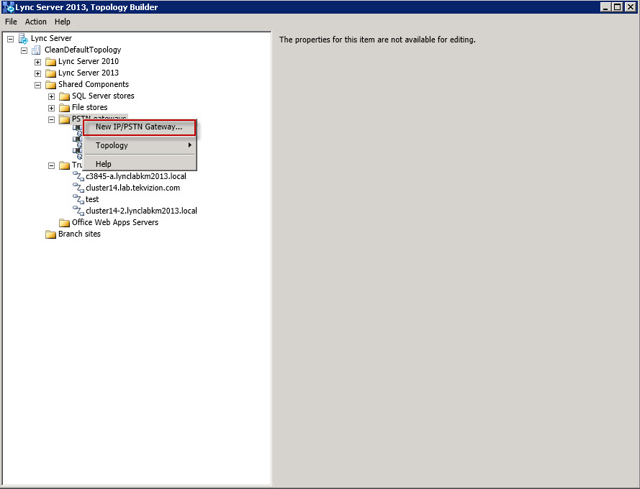
Figure 2: Configure PSTN Gateway -1

- Set FQDN: This is the IP Address or FQDN of the Cisco ISR Gateway.
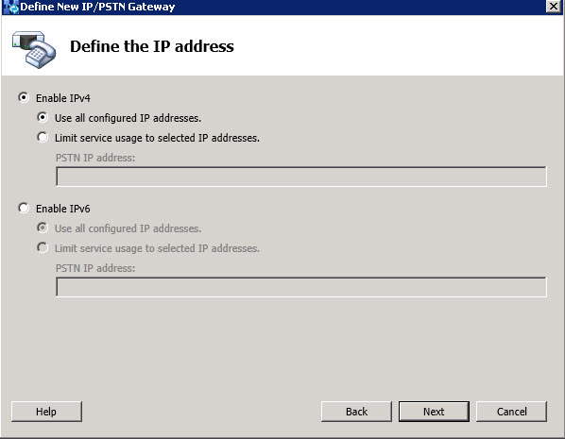
Figure 3: Configure PSTN Gateway -2

- Set Trunk Name: This is the FQDN of the ISR
- Set Listening port for IP/PSTN gateway: 5060 for TCP
- Set SIP Transport Protocol: TCP
- Set Associate Mediation Server: Assign this PSTN gateway to the Mediation Server. Medpool.lynclabkm2013.local is used here for example.
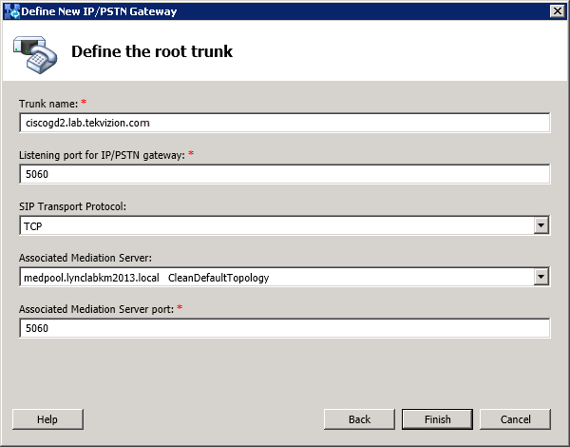
Figure 4: Configure PSTN Gateway -3

- Publish topology to make the changes effective, refer to below screen capture for the process.

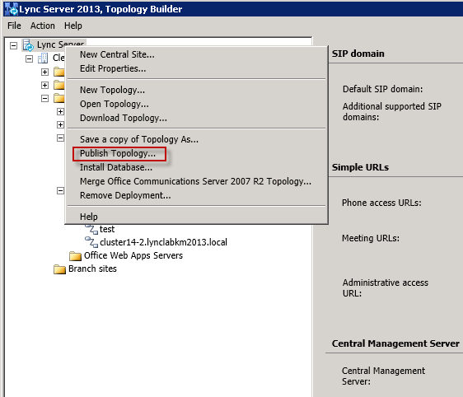
Figure 5: Publish Topology

Trunk Configuration
Navigation: Voice Routing -> Trunk Configuration
- Create a Pool Trunk by selecting New
- Select Service: Select the trunk to ISR you created in topology builder
- Set Maximum early dialogs supported: 20
- Set Encryption support level: Optional
- Set Refer Support: None
- Confirm Enable media bypass: is checked
- Confirm Centralized media processing: is checked
- Confirm Enable RTP latching: is unchecked
- Confirm Enable forward call history: is unchecked
- Confirm Enable forward P-Asserted-Identity data: is unchecked
- Confirm Enable outbound routing failover timer: is checked

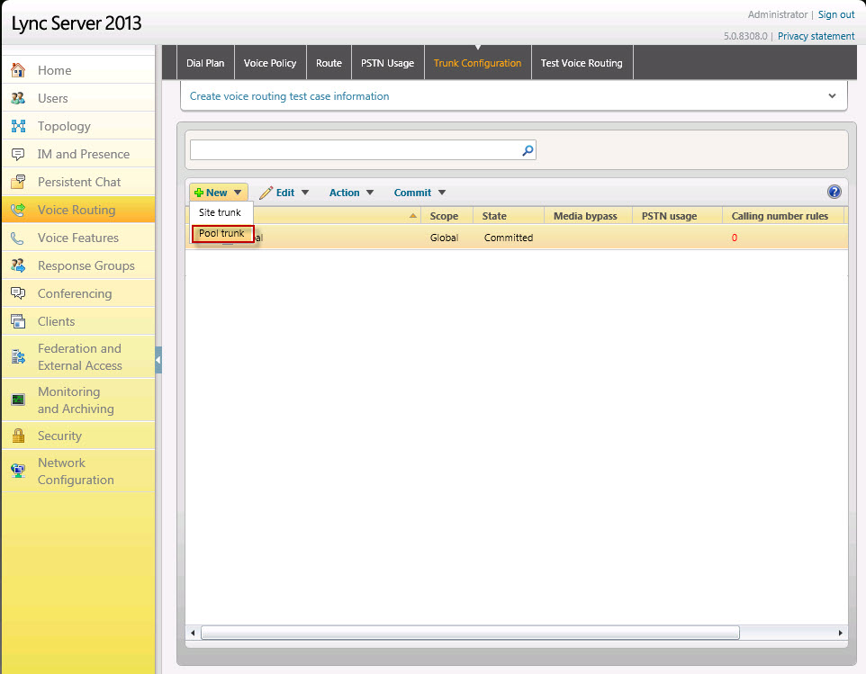
Figure 6: Trunk Configuration -1
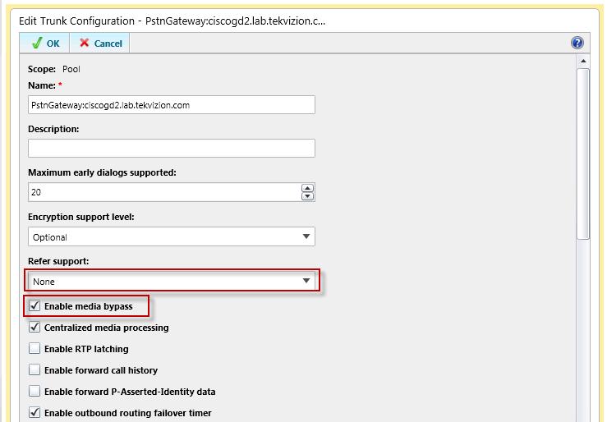
Figure 7: Trunk Configuration -2
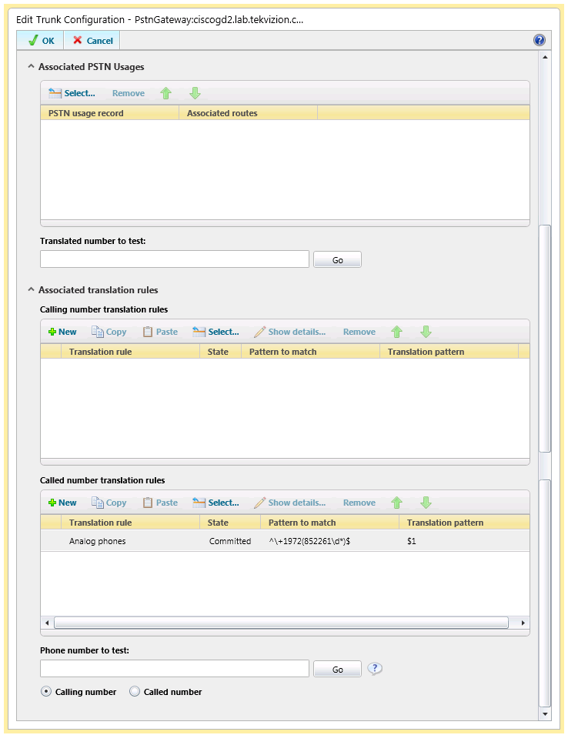
Figure 8: Trunk Configuration -3
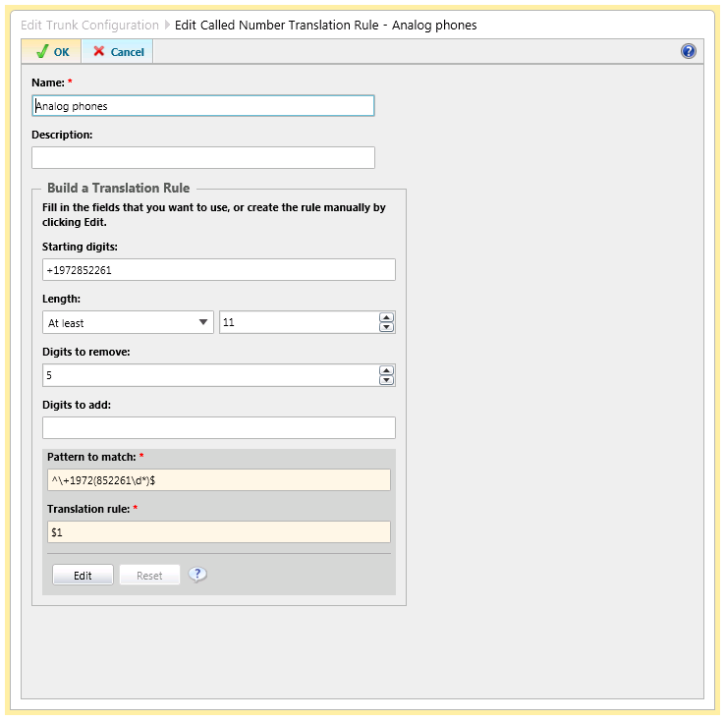
Figure 9: Called Number Translation Rule-Analog Phones

Route
Navigation: Voice Routing -> Route
- Set Name: Enter a name for this route
- Add Associated gateways: Add the gateway (ISR here) to which this route should send all the calls.
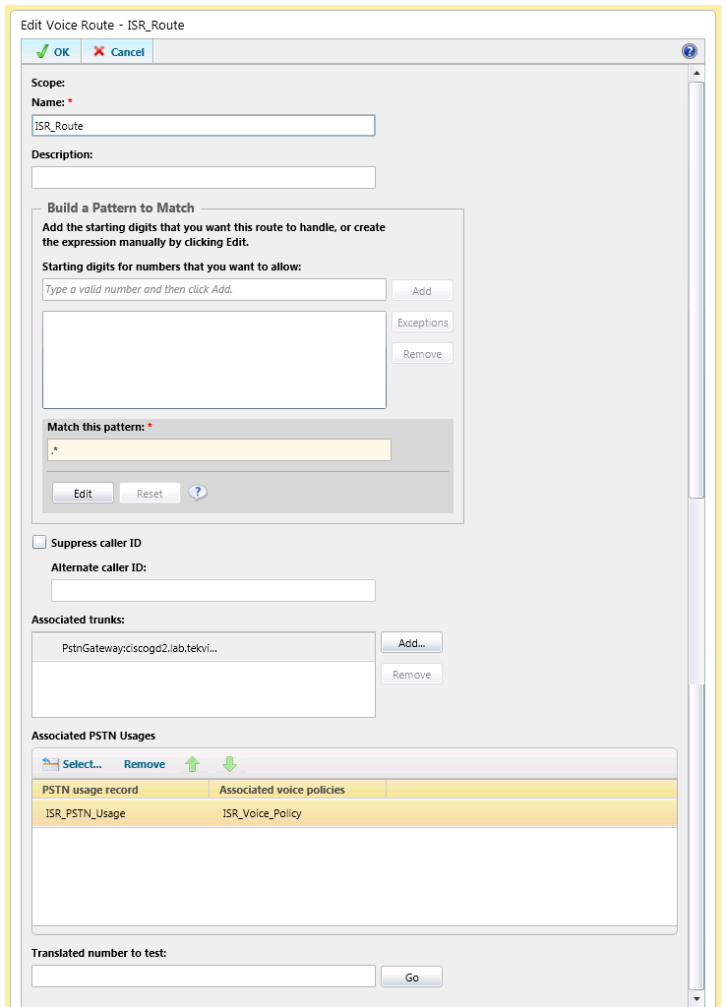
Figure 10: Route Configuration

Voice Policy and PSTN Usage
Navigation: Voice Routing -> Voice Policy
- Create a User policy by selecting New
- Set Name: Enter a name for this Voice Policy
- Set Calling Features:
  - Enable call forwarding : Checked
  - Enable delegation : Checked
  - Enable call transfer : Checked
  - Enable call park : Checked
  - Enable simultaneous ringing of phones : Checked
  - Enable team call : Checked
  - Enable PSTN reroute : Checked
  - Enable bandwidth policy override : Unchecked
  - Enable malicious call tracing : Unchecked
- Set Associated PSTN Usages:
  - Select New to create a new PSTN Usage
  - Set Name: Enter a name for this PSTN Usage
  - Set Associated Routes: Select the route you created under Voice Routing -> Route
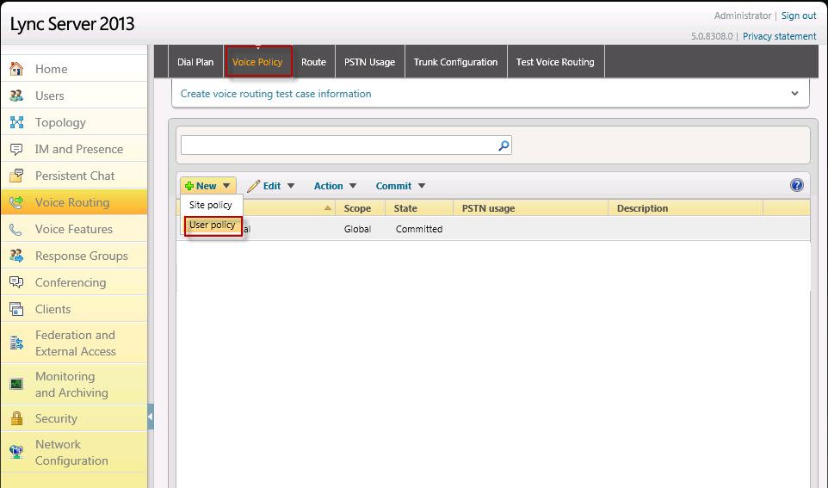
Figure 11: Voice Policy -1

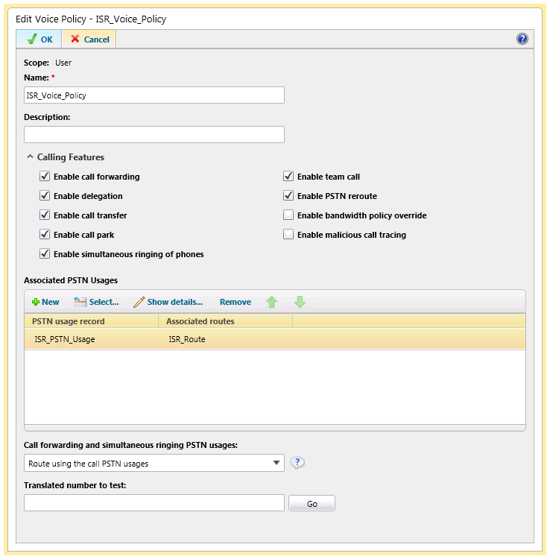
Figure 12: Voice Policy -2
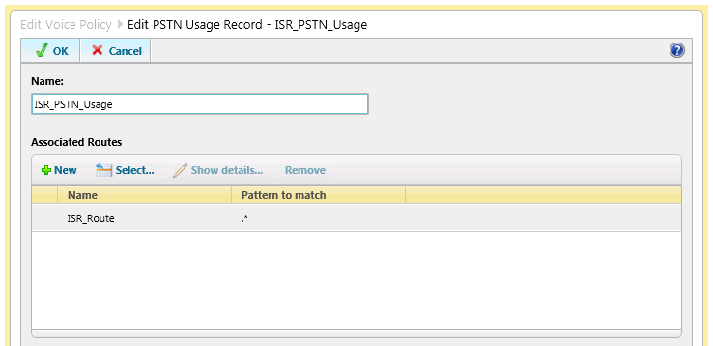
Figure 13: PSTN Usage

Dial Plan
Create a dial plan with normalization rules for all the enterprise and local voice calls.
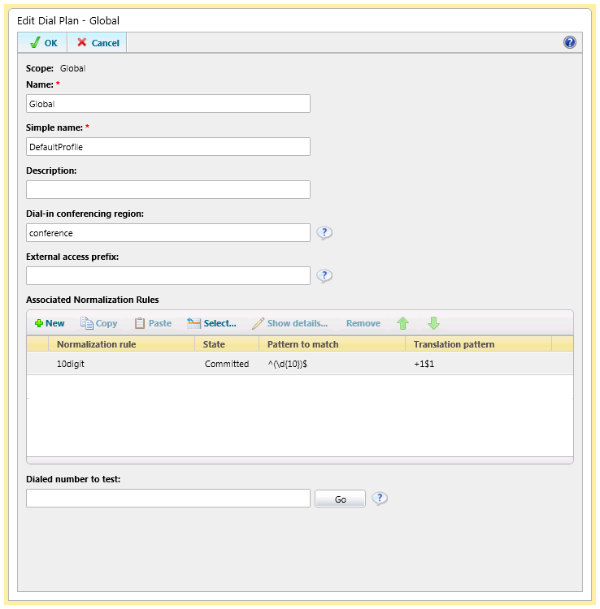

Configure Media Bypass
Navigation: Network Configuration -> Global
- Check ‘Enable media bypass’ in Global setting.
- Confirm you have also disabled media bypass in the trunk configuration
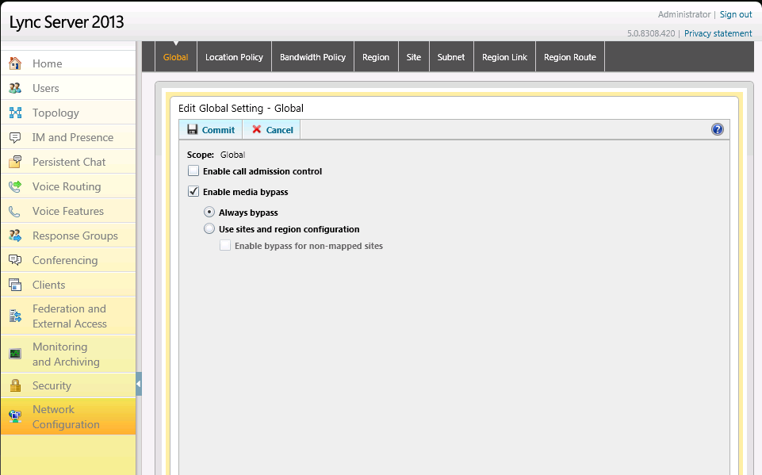
Figure 14: Media Bypass

Configure RTCP, Session Timer through the Windows PowerShell® command line interface because they are not configurable on Lync Server Control Panel
1. RTCPCallsonHold and RTCPActiveCalls must be turned off. RTCP is a control channel that is opened and is used to monitor the network specific conditions of the RTP channel. As REFER is disabled and Media Bypass is enabled on ISR Trunk, RTCP should be disabled on Lync Server.
Set-CsTrunkConfiguration –identity <Trunk name> –RTCPActiveCalls $false –RTCPCallsonHold $false
2. SessionTimer must be enabled. Because the RTCP channel is disabled, session timers must be enabled so that calls don’t stay up indefinitely in case we don’t get proper teardown of the call.
Set-CsTrunkConfiguration –identity <Trunk name> –EnableSessionTimer $true
3. Media EncryptionLevel must be set to SupportEncryption. Since we do not support SRTP to Cisco through Direct SIP, we need to set the media configuration’s EncryptionLevel to SupportEncryption so that SRTP will only be used if it can be negotiated. By default, this parameter is set to RequireEncryption, meaning SRTP must be used.
Set-CsMediaConfiguration –identity Global -EncryptionLevel SupportEncryption

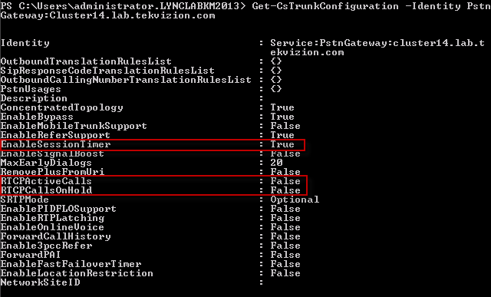
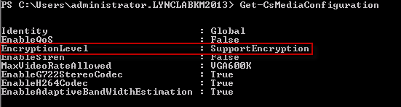

Host Name
Domain Name
IP Address of DNS Server
List of supported codecs in the order of preference
This is an example of the configuration required to enable call hold on Analog Endpoints. To make this active you must enter “service dsapp” in the voice dialpeer.
PRI interface on ISR Gateway
Dial peer for all calls going out to Lync
Dial peer for calls starting with +1 going out to PRI
Dial peer for analog port
Dial peer for calls to an Analog extension with 9728522617
Dial peer for calls to an Analog extension with 9728522618
Dial peer for calls going out to Lync with destination pattern 972852263.
Block 183 without sdp
Dial peer for calls going out from Analog extensions

