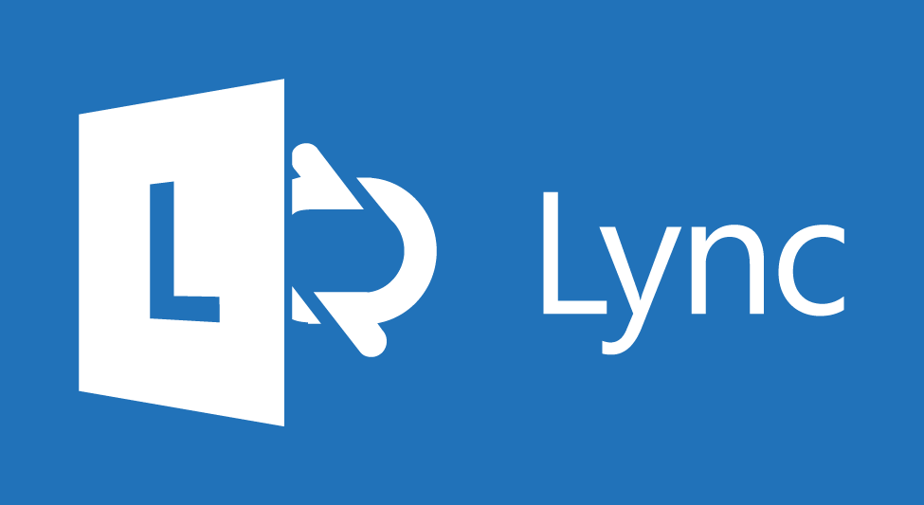

Microsoft Lync™ for Enterprises
Reference Topologies

Authors: Octavio Cárcamo, Aaron Steele and Jerry Loui
Published: August 2013
Updated: April 2014
Update includes a change to client support to add Lync 2010 for Windows client in a hybrid deployment when the user is homed in Lync Online.

For the latest information, please see Microsoft Lync at http://go.microsoft.com/fwlink/p/?LinkId=313432.

The information contained in this document represents the current view of Microsoft Corporation on the issues discussed as of the date of publication and is subject to change at any time without notice to you. This document is provided “as-is.” Information and views expressed in this document, including URL and other Internet Web site references, may change without notice. You bear the risk of using it. MICROSOFT MAKES NO WARRANTIES, EXPRESS OR IMPLIED, IN THIS DOCUMENT.
This document does not provide you with any legal rights to any intellectual property in any Microsoft product. You may copy and use this document for your internal, reference purposes. This document is confidential and proprietary to Microsoft. It is disclosed and can be used only pursuant to a non-disclosure agreement.
The descriptions of other companies’ products in this document, if any, are provided only as a convenience to you. Any such references should not be considered an endorsement or support by Microsoft. Microsoft cannot guarantee their accuracy, and the products may change over time. Also, the descriptions are intended as brief highlights to aid understanding, rather than as thorough coverage. For authoritative descriptions of these products, please consult their respective manufacturers.
Microsoft may have patents, patent applications, trademarks, copyrights, or other intellectual property rights covering subject matter in this document. Except as expressly provided in any written license agreement from Microsoft, the furnishing of this document does not give you any license to these patents, trademarks, copyrights, or other intellectual property.
All trademarks are the property of their respective companies.
©2014 Microsoft Corporation. All rights reserved.
Microsoft, Active Directory, Internet Explorer, MSN Messenger, Outlook, PowerPoint, RoundTable, SharePoint, Silverlight, Windows, Windows Live Messenger, Windows PowerShell, Windows Server, Windows SharePoint Services, Windows Vista, and Windows XP are either registered trademarks or trademarks of Microsoft Corporation in the United States and/or other countries.
The names of actual companies and products mentioned herein may be the trademarks of their respective owners.
Contents
Introduction 4
Lync Server Reference Topologies 5
Lync Server Topologies 7
Lync Online Topologies 11
Lync Server Hybrid Shared SIP Address 14
Appendix A: Feature Comparison Matrix 20
Appendix B: Lync Server Central Site Hardware Configurations 26
Example Central Site Configurations 27
10,001 to 20,000 Users 28
20,001 to 30,0000 Users 28
Appendix C: Lync Server Branch Site Resilience Options 29
Appendix D: Useful Links 30

Introduction
This document describes the reference topologies for the deployment of Lync Server 2013 on-premises, including the topologies supported for Lync Online and the topologies for Lync Server on-premises to connect to Lync Online and integrate with Exchange. This document also identifies the typical hardware configurations, key supportability requirements, and capabilities for each topology.

Lync Server Reference Topologies
The Lync Server 2013 Reference Topologies describe approaches that are recommended and supported by Microsoft for adding Lync capabilities to an enterprise IT infrastructure. They are characterized based on how customers choose to deploy Lync and Exchange. The Lync option chosen determines the Lync feature set, and the Exchange option chosen determines the supported Active Directory configurations.

The Lync Reference Topologies are designed to provide the full set of user capabilities offered by Lync Server or Lync Online. Also, they describe the customer options for providing Lync capabilities that are resilient to failures.
Table 1 summarizes the Lync Reference Topologies.

Topology | Description | Lync | Exchange
Lync Server | Everything On-premises | On-premises | On-premises
 | On-premises Lync Server and  Exchange Online | On-premises | O365
Lync Online | Lync Online and Exchange On-premises | O365 | On-premises
 | Everything Online | O365 | O365
Hybrid Lync Server  (split domain) | On-premises Lync Server (configured for hybrid with Lync Online) and Exchange On-premises | Hybrid | On-premises
 | On-premises Lync Server (configured for hybrid with Lync Online) and Exchange Online | Hybrid | O365
Table 1: Lync Reference Topologies
The reference topology descriptions include, where appropriate:

- The Lync capabilities defined by the topology
- The recommended Lync hardware configurations, if required, for central sites and branch sites
- The supported Active Directory topologies
For more information, see Supported Active Directory Topologies at http://go.microsoft.com/fwlink/p/?LinkId=313433.
- The supported mechanisms for synchronization between Lync and Exchange
- Options for Lync interoperability with the PSTN, (IP) PBX systems, and 3rd party video systems

The reference topologies do not describe the environmental attributes and operational processes recommended for Lync deployments, including, but not limited to, network characteristics, user training, and service level monitoring. In addition, the reference topologies do not include any information intended to inform selection of a topology other than the information described above.

Lync Server Topologies
There are two Lync Server topologies described in this document:

- Lync Server with Exchange Server
- Lync Server with Exchange Online

Table 2 summarizes the Lync Server Topologies.

 | On-premises | Online | Comments
Lync user is homed on-premises | - IM/P  - Conferencing  - Persistent Chat  - Enterprise Voice  - Exchange Server | N/A | On-premises only
 | - IM/P  - Conferencing  - Persistent Chat  - Enterprise Voice | Exchange Online | Voice delivered through on-premises infrastructure
Table 2: Lync Server Topologies

Both of the Lync Server topologies share the following attributes:

- The Lync capabilities provided by a Lync Server topology (see Appendix A)
- The recommended Lync hardware configurations for central sites (see Appendix B). At least one central site is required in a Lync Server topology. The central site configurations vary by the number of users served by the Lync hardware configuration in that site.
- The recommended options for providing resilient communications to users located in branch sites (see Appendix C). Customers may choose between these options for each branch site.
- Options for Lync Server interoperability with the PSTN.
- Options for Lync Server interoperability with (IP) PBX systems.
- Options for Lync Server interoperability with 3rd party video systems.

The Lync Server topologies vary in:

- The supported Active Directory topologies
For more information see Supported Active Directory Topologies at http://go.microsoft.com/fwlink/p/?LinkId=313433.
- The synchronization mechanism between customer Active Directory and the Microsoft Online Services cloud.
- The supported mechanisms for integration between Lync and Exchange
- Any unique requirements for the deployment or configuration of Lync or Exchange Edge Servers

The following two tables characterize the Lync Server topologies. The first table shows the attributes that are common across the topologies; the second table shows the attributes that vary by topology.

Attributes Common to all Lync Server Topologies
Lync Server topology | Lync Server with Exchange Server | Lync Server with Exchange Online
Summary graphic | 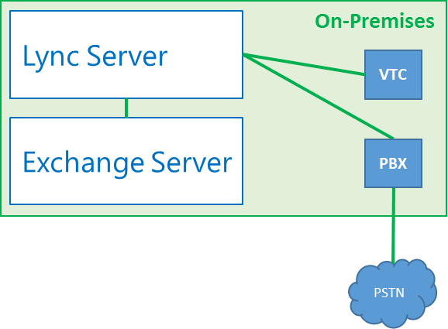 | 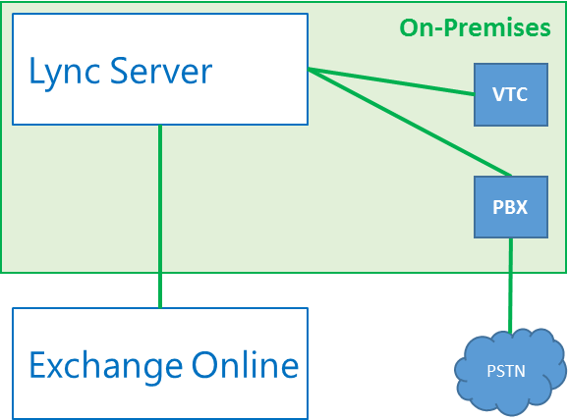
Attribute | Description
Lync capabilities | See Lync Server column in Appendix A
Recommended central site configurations | Select Appendix B option based on total number of users
Recommended branch site configurations | Select Appendix C option based on customer criteria
Options for PSTN interoperability | - Use any SIP Trunking Service qualified to meet UCOIP requirements. For more information, see the Services -> SIP Trunking tab on the Services qualified for Microsoft Lync page at http://go.microsoft.com/fwlink/p/?LinkId=313434.  - Use PSTN TDM trunks connected to any basic gateway or enhanced gateway qualified to meet UCOIP requirements. For more information, see the Infrastructure -> Qualified IP-PBXs & Gateways option on the Infrastructure qualified for Microsoft Lync page at http://go.microsoft.com/fwlink/p/?LinkId=313435.
Options for PBX and IP PBX interoperability | - Use Direct SIP to any IP PBX qualified to meet UCOIP requirements or otherwise supported by Microsoft. For more information, see the Infrastructure -> Supported IP-PBXs option on the Infrastructure qualified for Microsoft Lync page at http://go.microsoft.com/fwlink/p/?LinkId=313435.  - Use PBX TDM trunks connected to any basic gateway or enhanced gateway qualified to meet UCOIP requirements. For more information, see the Infrastructure -> Qualified IP-PBXs & Gateways option on the Infrastructure qualified for Microsoft Lync page at http://go.microsoft.com/fwlink/p/?LinkId=313435.
Options for 3rd party video system (VTC) interoperability | For more information about third party endpoints and multipoint conference bridges qualified for use with Lync Server 2013. For more information, see Video solutions qualified for Lync at http://go.microsoft.com/fwlink/p/?LinkId=313436.

Attributes that vary by Lync Server Topologies
Lync Server topology | Lync Server with Exchange Server | Lync Server with Exchange Online
Attribute | Description | Description
Supported Active Directory (AD) topologies | Single or Multiple Forest as described in Supported Active Directory Topologies at http://go.microsoft.com/fwlink/p/?LinkId=313433 and Preparing Active Directory Domain Services for Lync Server 2013 at http://go.microsoft.com/fwlink/?LinkId=313437. | Single or Multiple Forest as described in Supported Active Directory Topologies at http://go.microsoft.com/fwlink/p/?LinkId=313433 and Preparing Active Directory Domain Services for Lync Server 2013 at http://go.microsoft.com/fwlink/?LinkId=313437.
Exchange UM Integration | Follow the configuration outlined in On-Premises Exchange Unified Messaging Integration at http://go.microsoft.com/fwlink/p/?LinkId=313438. | Requires a Lync Server 2013 Edge Server and to follow the the steps described in Configuring On-premises Lync Server 2013 Integration with Exchange Online at http://go.microsoft.com/fwlink/p/?LinkId=313439 for connection to Online Services.
Constraints specific to 3rd party hosting of Exchange Server | Single or Multiple Forest, the steps described in Supported Active Directory Topologies at http://go.microsoft.com/fwlink/p/?LinkId=313433 must be followed. | Single or Multiple Forest, the steps described in Supported Active Directory Topologies at http://go.microsoft.com/fwlink/p/?LinkId=313433 must be followed.

Lync Online Topologies
There are two Lync Online topologies:

- Lync Online with Exchange Server
- Lync Online with Exchange Online

Table 3 summarizes the Lync Online Topologies.

 | On-premises | Online | Comments
Lync user is homed online | Exchange Server | - IM/P  - Conferencing
 | N/A | - IM/P  - Conferencing  - Exchange Online | Online only  Voice delivered through Hosted Partner
Table 3: Lync Online Topologies
Each of the Lync Online topologies share the following attributes:

- No on premises Lync hard ware is required in central sites
- No on premises Lync hardware is required in branch sites
- No on premises options are provided for interoperability with 3rd party video systems.

The Lync Online topologies vary in:

- The Lync capabilities provided by the Lync Online topology. See Appendix A for details.
- The supported Active Directory topologies
- The supported mechanisms for integration between Lync and Exchange
- Any unique requirements for the deployment or configuration of Lync or Exchange Edge Servers

The following two tables characterize the Lync Online topologies. The first table shows the attributes that are common across the topologies; the second table shows the attributes that vary by topology.

Attributes Common to all Lync Online Topologies
Lync Online topology | Lync Online with Exchange Server | Lync Online with Exchange Online
Summary graphic | 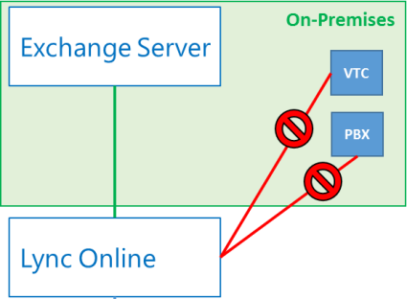 | 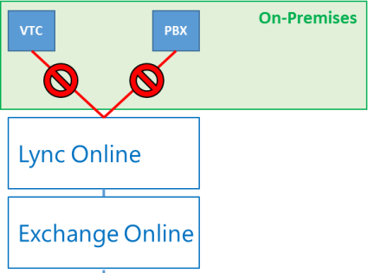
Attribute | Description
Recommended central site configurations | Not applicable. No Lync infrastructure is required on premises.
Recommended branch site configurations | Not applicable. No Lync infrastructure is required on premises.
Options for 3rd party video system interoperability | Not applicable. Interoperability with 3rd party video systems is not supported.
Constraints specific to 3rd party hosting of Lync Server and Exchange Server | None

Attributes that vary by Lync Online Topology
Lync Online topology | Lync Online with Exchange Server | Lync Online with Exchange Online
Attribute | Description | Description
Lync capabilities | See Lync Online column  in Appendix A | See Lync Online column  in Appendix A
Options for PSTN Interoperability | None | None
Options for PBX and IP PBX Interoperability | None | None
Supported Active Directory Topologies | As described in Directory integration overview at http://go.microsoft.com/fwlink/p/?LinkId=313440. | As described in Directory integration overview at http://go.microsoft.com/fwlink/p/?LinkId=313440.

Lync Server Hybrid Shared SIP Address
A hybrid deployment is a deployment in which some users are homed on-premises and some users are homed online, but the users share the same domain, such as contoso.com.

You can configure your on-premises deployment for hybrid with Lync Online and use Active Directory Synchronization to keep your on-premises and online users synchronized. You can also configure hybrid deployments for integration with other Microsoft Office 365 applications, including Exchange Online and SharePoint Online. This section guides you through deploying the applications required for a Lync Server hybrid deployment, and then configuring your deployment to enable it.
There are differents options combinations to enable the differents services with Exchange UM, basically we have four scenarios:

- Lync Online users in Lync hybrid with Exchange On-premises
- Lync On-premises user in Lync hybrid with Exchange On-premises
- Lync Online user in Lync hybrid with Exchange Online
- Lync On-premises user in Lync hybrid with Exchange Online

Table 4 summarizes the Lync Server hybrid topologies by feature support.

 | On-premises | Online
Lync user is homed online | Exchange Server | - IM/P  - Conferencing
Lync user is homed on-premises | Exchange Server
- IM/P
- Conferencing
- Persistent Chat
- Enterprise Voice
Lync user is homed online |  | Exchange Server
- IM/P
- Conferencing
Lync user is homed on-premises |  | Exchange Server
- IM/Presence
- Conferencing
- Persistent Chat
- Enterprise Voice
Table 4: Lync Hybrid Topologies
Note: The user should be homed on-premises to gain Enterprise Voice functionality

Attributes Common to all Lync Hybrid Topologies
Lync Hybrid topology | Lync User homed Online | Lync User homed On-premises
Summary graphic | 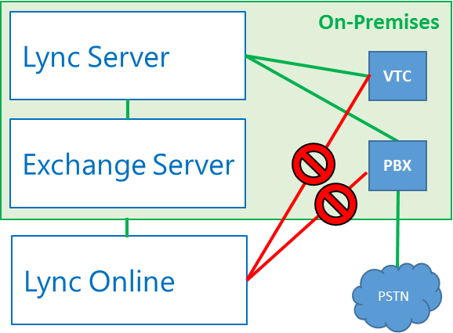 | 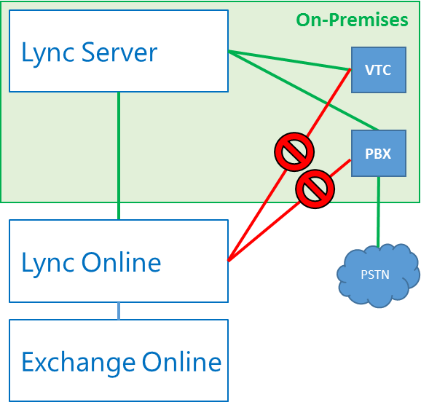
Attribute | Description
Recommended central site configurations | Select Appendix B option based on total number of users homed on-premises
Recommended branch site configurations | Select Appendix C option based on customer criteria
Tenant | An Office 365 tenant running Lync Online 2013.
On-premises Deployment | Lync Server 2013 on-premises deployment.
AD FS | - An Active Directory Federation Services (AD FS) see
Directory Synchronization | A Directory Synchronization server. For more information, see Directory Synchronization Tool at http://go.microsoft.com/fwlink/p/?LinkID=231010.
Lync Topology requirements | One of the following:  - Microsoft Office Communications Server 2007 R2 with Lync Server 2013 on-premises. The Lync Server 2013 federation Edge Server and the next hop server from the federation Edge Server must be running Lync Server 2013, and there must be a Central Management Store deployed. The Edge Server and pool must be deployed on-premises.  - Microsoft Lync Server 2010 with Cumulative Updates for Lync Server 2010: February 2013. The federation Edge Server and next hop server from the federation Edge Server must be running Microsoft Lync Server 2010 with the latest cumulative updates.  - A Lync Server 2013 deployment with all servers running Lync Server 2013.
Federation Block/Allow list | - Domain matching must be configured the same for your on-premises deployment and your Office 365 tenant. If partner discovery is enabled on the on-premises deployment, then open federation must be configured for your online tenant. If partner discovery is not enabled, then closed federation must be configured for your online tenant.  - The Blocked domains list in the on-premises deployment must exactly match the Blocked domains list for your online tenant.  - The Allowed domains list in the on-premises deployment must exactly match the Allowed domains list for your online tenant.  - Federation must be enabled for the external communications for the online tenant, which is configured by using the Lync Online Control Panel.
DNS | The records, _sipfederationtls._tcp.<domain> and _sip._tls.<domain>, should point to the on-premises Access Proxy.
User Accounts/Data | - Any user that you want to home in Lync Online must first be created in the on-premises deployment, so that the user account is created in Active Directory Domain Services. You can then move the user to Lync Online, which will move the user’s contact list.  - The limit for contacts for Lync Online users is 250. Any contacts beyond that number will be removed from the user’s contact list.  - User contact lists, groups, and access control lists (ACLs) are migrated with the user account.  - This content is not migrated with the user account. Users must reschedule meetings after their accounts are migrated to Lync Online.
Policies and configuration | Online and on-premises policies require separate configuration. You cannot set global policies that apply to both.
Table 5: Lync Hybrid Commonalities

Attributes that vary by Lync Online Topology
Lync Hybrid topology | Lync User homed Online | Lync User homed On-premises
Attribute | Description | Description
Options for PSTN Interoperability | None | Use any SIP Trunking Service qualified to meet UCOIP requirements. For more information, see the Services -> SIP Trunking tab on the Services qualified for Microsoft Lync page at http://go.microsoft.com/fwlink/p/?LinkId=313434..  Use PSTN TDM trunks connected to any basic gateway or enhanced gateway qualified to meet UCOIP requirements. For more information, see the Infrastructure -> Qualified IP-PBXs & Gateways option on the Infrastructure qualified for Microsoft Lync page at http://go.microsoft.com/fwlink/p/?LinkId=313435.
Options for PBX and IP PBX Interoperability | None | Use Direct SIP to any IP PBX qualified to meet UCOIP requirements or otherwise supported by Microsoft. For more information, see the Infrastructure -> Supported IP-PBXs option on the Infrastructure qualified for Microsoft Lync page at http://go.microsoft.com/fwlink/p/?LinkId=313435.  Use PBX TDM trunks connected to any basic gateway or enhanced gateway qualified to meet UCOIP requirements. For more information, see the Infrastructure -> Qualified IP-PBXs & Gateways option on the Infrastructure qualified for Microsoft Lync page at http://go.microsoft.com/fwlink/p/?LinkId=313435.
Options for 3rd party video system (VTC) interoperability | None | For more information, see Video solutions qualified for Lync at http://go.microsoft.com/fwlink/p/?LinkId=313436 for third-party endpoints and multipoint conference bridges qualified for use with Lync Server 2013.
Table 6: Lync Hybrid Differences

Exchange Integration Support
The following table lists the features supported in a hybrid deployment when integrated with Microsoft Exchange Server.
 | Exchange on-premises | Exchange Online
Lync Server 2013 on-premises | IM/Presence in Outlook  For more information, see IM and Presence at http://go.microsoft.com/fwlink/p/?LinkId=313472 | IM/Presence in Outlook  For more information, see Configuring On-premises Lync Server 2013 Integration with Exchange Online at http://go.microsoft.com/fwlink/p/?LinkId=313473
 | Schedule and join online meetings through Outlook  For more information, see Integrating Microsoft Lync Server 2013 and Microsoft Exchange Server 2013 at http://go.microsoft.com/fwlink/p/?LinkId=313520 | Schedule and join online meetings through Outlook
 | IM/Presence in Outlook Web App  For more information, see Configuring Microsoft Lync Server 2013 in a Cross-Premises Environment at http://go.microsoft.com/fwlink/p/?LinkId=313521 | IM/Presence in OWA  For more information, see Integrating Microsoft Lync Server 2013 and Microsoft Outlook Web App 2013 at http://go.microsoft.com/fwlink/p/?LinkId=313522
 | Schedule and join online meetings through Outlook Web App | Schedule and join online meeting from Outlook Web App For more information, see Integrating Microsoft Lync Server 2013 and Microsoft Outlook Web App 2013 at http://go.microsoft.com/fwlink/p/?LinkId=313522
 | IM/Presence in Mobile Clients | IM/Presence in Mobile Clients
 | Join online meetings in Mobile clients  For more information, see Deploying Mobility at http://go.microsoft.com/fwlink/p/?LinkId=313523 | Join online meeting in Mobile clients
 | Publish status based on Outlook calendar free/busy information | Publish status based on Outlook calendar free/busy information
 | Contact List (via Unified Contact Store)  For more information, see Configuring Microsoft Lync Server 2013 to Use the Unified Contact Store at http://go.microsoft.com/fwlink/p/?LinkId=313550  Note: A Lync 2013 client is required. | Contact List (via Unified Contact Store).  For more information, see Configuring Microsoft Lync Server 2013 to Use the Unified Contact Store at http://go.microsoft.com/fwlink/p/?LinkId=313550  Note: Lync Server 2013 only. A Lync 2013 client is required.
 | High-resolution Contact Photo in Lync 2013 client and Lync Web App.  For more information, see Configuring the Use of High-Resolution Photos in Microsoft Lync Server 2013 at http://go.microsoft.com/fwlink/p/?LinkId=313551 | High-resolution Contact Photo in Lync 2013 client and Lync Web App.  For more information, see Configuring the Use of High-Resolution Photos in Microsoft Lync Server 2013 at http://go.microsoft.com/fwlink/p/?LinkId=313551
 | Meeting delegation - Supported only when both users are homed online in the same forest, or both are homed on-premises. | Meeting delegation - Supported only when both users are homed online in the same forest, or both are homed on-premises.
 | Missed Conversations history and Call Logs are written to user’s exchange mailbox | Missed Conversations history and Call Logs are written to user’s exchange mailbox
 | Archiving Content (IM and Meeting) in Exchange  For more information, see Deployment Checklist for Archiving at http://go.microsoft.com/fwlink/p/?LinkId=313552 | Archiving Content (IM and Meeting) in Exchange  For more information, see Deployment Checklist for Archiving at http://go.microsoft.com/fwlink/p/?LinkId=313552
 | Search archived content | Search archived content  For more information, see Configure Exchange for SharePoint eDiscovery Center at http://go.microsoft.com/fwlink/p/?LinkId=285448
 | Voice mail  For more information, see Deploying On-Premises Exchange UM to Provide Lync Server 2013 Voice Mail at http://go.microsoft.com/fwlink/p/?LinkId=313554 | Voice mail  For more information, see Providing Lync Server 2013 Users Voice Mail on Hosted Exchange UM at http://go.microsoft.com/fwlink/p/?LinkId=313555
Lync Online | Exchange on-premises | Exchange Online
 | IM and Presence in Outlook | IM/Presence in Outlook
 | Schedule and join online meetings through Outlook | Schedule and join online meetings through Outlook
 | IM/Presence in Mobile clients | IM/Presence in Mobile Clients
 | IM/Presence in Outlook Web App | IM/Presence in Outlook Web App
 | Schedule and join online meeting from Outlook Web App | Schedule and join online meeting from Outlook Web App
 | High-resolution Contact Photo in Lync 2013 client. Not supported in Lync Web App when users are homed on Lync Online. | High-resolution Contact Photo in Lync 2013 client and Lync Web App
 | Join online meeting in Mobile clients | Join online meeting in Mobile clients
 | Publish status based on Outlook calendar free/busy information | Publish status based on Outlook calendar free/busy information
 | Meeting delegation. Supported only when both users are homed online in the same forest, or both are homed on-premises. | Meeting delegation. Supported only when both users are homed online in the same forest, or both are homed on-premises.
 | Missed Conversations history and Call Logs are written to user’s exchange mailbox | Missed Conversations history and Call Logs are written to user’s exchange mailbox
 |  | Contact List (via Unified Contact Store) Lync Server 2013 client Required
 |  | Archiving Content (IM and Meeting) in Exchange
 |  | Search archived content
 |  | Voicemail
Table 7: Exchange Integrations

Appendix A: Feature Comparison Matrix

Features | Lync Server | Lync Online | Hybrid Lync Server  (User on premise) | Hybrid Lync Server  (User online)
Lync 2013 for Windows | Supported | Supported | Supported | Supported
Online Meeting Add-in for Lync 2013 | Supported | Supported | Supported | Supported
Lync 2013 Web Scheduler | Supported | Supported | Supported | Supported
Lync Online Web Scheduler | N/A | Supported | N/A | Supported
Lync Web App 2013 | Supported | Supported | Supported | Supported
Lync 2013 Basic | Supported | Supported | Supported | Supported
Lync Windows Store App | Supported | Supported | Supported | Supported
Lync 2013 for Windows Phone | Supported | Supported | Supported | Supported
Lync 2013 for iPhone | Supported | Supported | Supported | Supported
Lync 2013 for Android Phones | Supported | Supported | Supported | Supported
Lync 2010 for Windows | Supported | Supported | Supported | Supported
Online Meeting Add-in for Lync 2010 | Supported | Not Supported | Supported | Not Supported
Lync 2010 for Windows Phone | Supported | Not Supported | Supported | Not Supported
Lync 2010 for iPhone | Supported | Not Supported | Supported | Not Supported
Lync 2010 for Android | Supported | Not Supported | Supported | Not Supported
Lync Phone Edition | Supported | Supported | Supported | Supported
Lync Server 2010 Attendant | Supported | Not Supported | Supported | Not Supported
Lync 2010 Group Chat | N/A | Not Supported | N/A | Not Supported
Lync Web App 2010 | Not Supported | Not Supported | Not Supported | Not Supported
Lync 2010 Attendee | Not Supported | Not Supported | Not Supported | Not Supported
Lync for Mac 2011 | Supported | Supported | Supported | Supported
Communicator for Mac 2011 | Supported | Not Supported | Supported | Not Supported
Office Communicator 2007 R2 | Interoperable | Not Supported | Interoperable | Not Supported
Office Communicator 2007 R2 Conferencing Add-in | Not Supported | Not Supported | Not Supported | Not Supported
Microsoft Office Communications Server 2007 R2 Attendant | Not Supported | Not Supported | Not Supported | Not Supported
Office Communicator 2007 | Not Supported | Not Supported | Not Supported | Not Supported
Office Live Meeting 2007 | Not Supported | Not Supported | Not Supported | Not Supported
Communicator Mobile for Windows Mobile 6.x | Not Supported | Not Supported | Not Supported | Not Supported
BlackBerry Enterprise Server 5.0 SP4 Maintenance Release 2 integration for the BlackBerry client with the Lync Server 2013 | Supported | Not Supported | Supported | Not Supported
Peer-to-Peer instant messaging (IM) and presence | Supported | Supported | Supported | Supported
Multiparty IM and presence | Supported | Supported | Supported | Supported
Contact Card in Office 2013 (incl. click to communicate) | Supported | Supported | Supported | Supported
Photo Configuration | Supported | Supported | Supported | Supported
Contact List Configuration | Supported | Supported | Supported | Supported
Contact Card Configuration | Supported | Supported | Supported | Supported
Address Book search | Supported | Supported | Supported | Supported
Distribution list expansion | Supported | Supported | Supported | Supported
Persistent Chat | Supported | Not Supported | Supported | Not Supported
Desktop sharing | Supported | Supported | Supported | Supported
Application sharing | Supported | Supported | Supported | Supported
File transfers | Supported | Supported | Supported | Supported
Voice | Supported | Supported | Supported | Supported
Video | Supported | Supported  (up to VGA) | Supported | Supported  (up to VGA)
IM, presence, audio, video and conferencing federation with Office Communicator 2007 R2 and Lync 2010 | Supported | Supported | Supported | Supported
IM, presence, audio, and video federation with Skype | Supported | Not Supported | Supported | Not Supported
IM and presence federation with IBM Sametime | Supported | Supported | Supported | Supported
IM and presence federation with customer hosted XMPP gateway | Supported | Not Supported | Supported | Not Supported
IM and presence federation with GChat thorugh XMPP | Supported | Not Supported | Supported | Not Supported
Meeting attendee capacity | 1000 | 250 | 1000 | 250
Ad-hoc and scheduled audio conferencing | Supported | Supported | Supported | Supported
Ad-hoc and scheduled video conferencing | Supported | Supported | Supported | Supported
Ad-hoc and scheduled web conferencing | Supported | Supported | Supported | Supported
Dial-in PSTN Conferencing via customer trunks | Supported | Not Supported | Supported | Not Supported
Dial-in PSTN Conferencing via certified Audio Conferencing Provider (ACP) | Supported | Supported | Supported | Supported
Desktop sharing | Supported | Supported | Supported | Supported
Application sharing | Supported | Supported | Supported | Supported
File transfer | Supported | Supported | Supported | Supported
White boarding and annotations | Supported | Supported | Supported | Supported
PowerPoint upload | Supported | Supported | Supported | Supported
Polling | Supported | Supported | Supported | Supported
Client-side recording and playback | Supported | Supported | Supported | Supported
Meeting lobby | Supported | Supported | Supported | Supported
Participant anonymous join via Lync Web App | Supported | Supported | Supported | Supported
Participant anonymous join via Lync Attendee | Supported | Supported | Supported | Supported
Schedule Lync meeting through Outlook | Supported | Supported | Supported | Supported
Schedule Lync meeting on behalf of another user through Outlook (delegation) | Supported | Not Supported | Supported | Not Supported
Scheduled conferences using web page | Supported | Supported | Supported | Supported
Outlook delegation for scheduling meetings | Supported | Supported | Supported | Supported
Peer to peer VoIP calling | Supported | Supported | Supported | Supported
PSTN calling | Supported | Not Supported | Supported | Not Supported
Exchange voice mail | Supported | Supported  (with Exchange Online only) | Supported | Supported  (with Exchange Online only)
PC, Mac, Windows Phone, iOS, and Android phone support | Supported | Supported | Supported | Supported
IP Phone support | Supported | Not Supported | Supported | Not Supported
Common area phone support | Supported | Not Supported | Supported | Not Supported
Analog device support | Supported | Not Supported | Supported | Not Supported
Call hold, transfer, forward, delegation, team calling (PSTN) | Supported | Not Supported | Supported | Not Supported
Call park, private line, malicious call trace (PBX) | Supported | Not Supported | Supported | Not Supported
Emergency dialing (911, 112, etc.) | Supported | Not Supported | Supported | Not Supported
Enhanced 911 (US only) | Supported | Not Supported | Supported | Not Supported
Response groups | Supported | Not Supported | Supported | Not Supported
Integration with on-premises call center solutions (e.g., Aspect, NICE Systems) | Supported | Not Supported | Supported | Not Supported
Outgoing DID manipulation | Supported | Not Supported | Supported | Not Supported
Dial plans and policies | Supported | Not Supported | Supported | Not Supported
Intercept for Unassigned number | Supported | Not Supported | Supported | Not Supported
Local voice resiliency | Supported | Not Supported | Supported | Not Supported
Voice call Interoperability with PSTN | Supported | Not Supported | Supported | Not Supported
Voice call Interoperability with third-party PBX | Supported | Not Supported | Supported | Not Supported
RCC with third-party PBX | Supported | Not Supported | Supported | Not Supported
Audio quality of service (QoS) | Supported | Not Supported | Supported | Not Supported
Video quality of service (QoS) | Supported | Not Supported | Supported | Not Supported
Audio call admission control (CAC) | Supported | Not Supported | Supported | Not Supported
Video call admission control (CAC) | Supported | Not Supported | Supported | Not Supported
Media bypass | Supported | Not Supported | Supported | Not Supported
IM and media encryption | Supported | Supported | Supported | Supported
IM and file filtering | Supported | Supported | Supported | Supported
Client version control | Supported | Supported | Supported | Supported
Anti-malware scanning of uploaded meeting content | Supported  (3rd party application) | Not Supported | Supported  (3rd party application) | Not Supported
Anti-malware scanning of file transfer content | Supported  (3rd party application) | Not Supported | Supported  (3rd party application) | Not Supported
IM (Instant Messaging) content archiving | Supported | Not Supported | Supported | Not Supported
Presence interoperability with Exchange Server | Supported | Supported | Supported | Supported
Presence Interoperabiity with Exchange Online | Supported | Supported | Supported | Supported
Unified Messaging interoperability with Exchange Server | Supported | Not Supported | Supported | Not Supported
Unified Messaging interoperability with Exchange Online | Supported | Supported | Supported | Supported
Outlook Web App interoperability | Supported  (Exchange Server only) | Supported  (Exchange Online only) | Supported  (Exchange Server only) | Supported  (Exchange Online only)
Skill Search with SharePoint Server | Supported | Not Supported | Supported | Not Supported
Skill Search with SharePoint Online | Not Supported | Not Supported | Not Supported | Not Supported
PowerShell support | Supported | Supported | Supported | Supported
Lync Control Panel | Supported | Not Supported | Supported | Not Supported
Reporting (CDR, QoE) | Supported | Not Supported | Supported | Not Supported
Self-service configuration portal | N/A | Supported | N/A | Supported
Client updated via inband provisioning | Supported | Supported | Supported | Supported
Lync client-side automation using Microsoft SDK | Supported | Supported | Supported | Supported
Lync server-side APIs using Microsoft SDK | Supported | Supported | Supported | Supported
Customer clients using Microsoft SDK | Supported | Supported | Supported | Supported

Appendix B: Lync Server Central Site Hardware Configurations
Each Lync Server deployment must include at least one central site (also known as a data center) as described in Supported Lync Server 2013 Topologies at http://go.microsoft.com/fwlink/p/?LinkId=313559. Each central site must contain at least one of the following:
- A Standard Edition server
- An Enterprise Edition Front End pool and a separate Back End Server

Your deployment can also have one or more branch sites associated with a central site.

A central site topology may also contain the following elements:
- Mediation server or pool, for scalability of transcoding functions for dial-in conferencing and PSTN/PBX access separate from the front end server pool
- Edge server or pool, for encrypted remote access over the Internet
- Monitoring, for data collection of audio/video Quality of Experience (QoE) and call detail recording (CDR) for Enterprise Voice and A/V conferences. Monitoring, when deployed, is collocated on Front End Servers or a Standard Edition server.
- Archiving, for archiving IM communications and meeting content for compliance reasons. Archiving, when deployed, is collocated on Front End Servers or a Standard Edition server.
- Director or Director pool, for increased protection against Denial-of-Service (DoS) attacks and redirection of user requests.

In addition to the Lync components noted above, a deployment often includes additional elements including PSTN Gateways, DNS load balancing and hardware load balancers, Reverse proxies, Exchange UM servers, and file shares. Additional information may be found in the Lync 2013 Planning documentation including Supported Lync Server 2013 Topologies at http://go.microsoft.com/fwlink/p/?LinkId=313559.

Detailed planning should be done with knowledge of expected usage of IM and presence, Lync meetings and enterprise voice using formal resources including the Lync Server Capacity Planning Using the User Models documentation at http://go.microsoft.com/fwlink/p/?LinkId=313564, the associated Microsoft Lync Server 2013 Capacity Calculator at http://go.microsoft.com/fwlink/p/?LinkId=313566, and Database Software and Clustering Support documentation at http://go.microsoft.com/fwlink/p/?LinkId=313570.

Budgetary planning may be done using the following rules-of-thumb:
- For proof of concept and other deployments not expected to grown beyond 5,000 users, Lync Standard Edition Server is a very effective option. A Standard Edition Server provides presence, instant messaging, audio, video, and web conferencing, and voice, and includes an integrated SQL Express back-end database. We strongly recommend that if you use Standard Edition servers to host users, you always use two servers, paired using the recommendations in Planning for High Availability and Disaster Recovery at http://go.microsoft.com/fwlink/p/?LinkID=273767. Each server in the pair can host up to 2,500 users, and if one server fails the remaining server can support 5,000 users in a failover scenario. If your deployment includes a lot of audio or video traffic, server performance may suffer even if you have fewer than 2,500 users per server. In this case, you should consider adding more Standard Edition servers or moving to Lync Server Enterprise Edition.
- For deployments of greater than 5,000 users, Lync Enterprise Edition (EE) is recommended.
  - To ensure high availability for Front End Servers, deploy a minimum of three Front End Servers for a single EE Front End pool
    - Information about a particular user is kept on three Front End Servers in the pool. For each user, one Front End Server acts as the master for that user’s information, and two other Front End Servers serve as replicas. We recommend that all your Enterprise Edition Front End pools include at least three Front End Servers, to provide the full number of replicas that the Front End pool architecture is designed for.
    - Plan for one EE Front End (FE) server per 6,600 users for IM, presence, and enterprise voice
    - Consider additional stand-alone Mediation Servers if the entire organization will rely on PSTN SIP trunking for PSTN access.
  - To ensure high availability for your Back End Servers, deploy two Back End Servers for a single Front End pool, using synchronous SQL mirroring for all Lync EE deployments, using Back End Server High Availability at http://go.microsoft.com/fwlink/p/?LinkId=313573 as a reference.
- For both Standard Edition and Enterprise Edition deployments, plan for one Edge Server for each 12,000 remote users, plus one server for redundancy, if desired.
- For both Standard Edition and Enterprise Edition deployments, plan for collocating Monitoring and Archiving

For minimum server hardware recommendations, see Server Hardware Platforms at http://go.microsoft.com/fwlink/p/?LinkId=313577.

Example Central Site Configurations
The following section shows the recommended Lync configurations for supporting different numbers of users. The information is based on calculations from the Microsoft Lync Server 2013 Capacity Calculator, available at http://go.microsoft.com/fwlink/p/?LinkID=313566. All the CPU usage figures in the spreadsheet assume that each server has a dual processor, hex-core with 2.26 GHz, at least 32 GB of memory, and 8 or more 10,000-RPM hard disk drives with at least 72 GB free disk space.

Up to 10,000 Users
 |  | Predicted Lync Front End CPU Loading
Recommendations | Servers | IM/P | IM/P and Conferencing | IM/P, Conferencing, and Enterprise Voice
Front End Servers | 2 | 23% | 3% | 10%
Edge Servers  (based on 30% external) | 1
Archiving/CDR/QoE services Store | 1
Back End Servers | 1
Total | 4

10,001 to 20,000 Users
 |  | Predicted Lync Front End CPU Loading
Recommendations | Servers | IM/P | IM/P and Conferencing | IM/P, Conferencing, and Enterprise Voice
Front End Servers | 3 | 45% | 5% | 22%
Edge Servers  (based on 30% external) | 1
Archiving/CDR/QoE services Store | 1
Back End Servers | 1
Total | 5

20,001 to 30,0000 Users
 |  | Predicted Lync Front End CPU Loading
Recommendations | Servers | IM/P | IM/P and Conferencing | IM/P, Conferencing, and Enterprise Voice
Front End Servers | 5 | 67% | 6% | 33%
Edge Servers  (based on 30% external) | 1
Archiving/CDR/QoE services Store | 1
Back End Servers | 1
Total | 7

Aditional considerations for Edge Server deployment in a Lync Hybrid Split Domain Configuration

Appendix C: Lync Server Branch Site Resilience Options
Branch Site users get most of their Lync Server 2013 functionality from the server or servers at a Central Site. Each branch site is associated with exactly one Central Site. To provide calls to and from the public switched telephone network (PSTN), a branch site might rely on trunks terminated in the Central Site, or might contain local connections to the PSTN or a PBX.

If the branch site relies solely on trunks terminated in the Central Site, the only options for voice resiliency are to provide redundant network connections to the Central Site, either by replicating the wide area connection on the organization’s private network or by providing an Internet connection to the branch and using Lync Edge Services as a backup path in the case of private network failure. The Internet connection could take advantage of LTE or other 4G wireless technology to provide physical connection diversity.

If the branch site contains local connections to the PSTN or a PBX, voice resiliency may be provided via the deployment of local equipment as described in Planning for Branch Site Voice Resiliency at http://go.microsoft.com/fwlink/p/?LinkId=313582. Two primary options are provided:

- One or more Survivable Branch Appliances. Survivable Branch Appliances (SBAs) contain both industry standard server hardware (running Microsoft Lync Server Registrar and Mediation Server software) and a PSTN gateway. SBAs are purpose built as Lync appliances, and provide a continuous PSTN connection in the event of WAN failure, and do not require local IT support.
- A Survivable Branch Server. The Survivable Branch Server (SBS) is a Windows Server running Lync Server Registrar and Mediation Server software and capable of connecting to either PSTN gateways or SIP trunks. The SBS may be used with existing gateway hardware qualified for use with Lync, and does not require local IT support.

The primary consideration for choosing between an SBA and an SBS is whether existing gateway hardware will be re-used. For planning purposes, each SBA is assumed to support up to 1,000 users; each SBS is assumed to support up to 2,000 users. Gateway sizing should be done based on voice traffic patterns.

Appendix D: Useful Links

- Client Interoperability in Lync 2013 at http://go.microsoft.com/fwlink/p/?LinkId=313585
- Lync Online client comparison tables at http://go.microsoft.com/fwlink/p/?LinkId=313595
- Planning Directory Synchronization at http://go.microsoft.com/fwlink/p/?LinkId=313596
- Directory synchronization roadmap at http://go.microsoft.com/fwlink/p/?LinkID=254988
- Synchronize your directories at http://go.microsoft.com/fwlink/p/?LinkId=313597

The supported Active Directory topologies are a critical component of the Reference Topologies as Active Directory is used for user identification and authorization. Active Directory synchronization enables important end-user capabilities such as single sign-on and address book search.
All models except Polycom CX700 supported. Requires updated firmware http://support.microsoft.com/kb/2781619
All models except Polycom CX700 supported. Requires updated firmware http://support.microsoft.com/kb/2781619
Lync Web App 2013 now provides a full in-meeting experience, including computer audio and video, and is considered the replacement for Lync 2010 Attendee.
Lync Web App 2013 now provides a full in-meeting experience, including computer audio and video, and is considered the replacement for Lync 2010 Attendee.
The presence and IM features in Office Communicator 2007 R2 are compatible with Lync Server 2013, but conferencing features are not. During migration from Office Communications Server 2007 R2, Office Communicator 2007 R2 is suitable for presence and IM interoperability, but users should use Lync Web App 2013 to join Lync Server 2013 meetings.
The presence and IM features in Office Communicator 2007 R2 are compatible with Lync Server 2013, but conferencing features are not. During migration from Office Communications Server 2007 R2, Office Communicator 2007 R2 is suitable for presence and IM interoperability, but users should use Lync Web App 2013 to join Lync Server 2013 meetings.
Requires Sametime Gateway 8.0.2 with Hotfix 3 or later
Requires Sametime Gateway 8.0.2 with Hotfix 3 or later
Requires Sametime Gateway 8.0.2 with Hotfix 3 or later
Requires Sametime Gateway 8.0.2 with Hotfix 3 or later
Requires special Lync server configuration and policy to support meetings over 250.
Requires special Lync server configuration and policy to support meetings over 250.
Requires end user manual ACP dial-in
Requires end user manual ACP dial-in
A limited set of settings are available to be controlled via in-band provisioning by the service.
A limited set of settings are available to be controlled via in-band provisioning by the service.

